

Student Name
Yang Liu
Student Number
230482
Module Title
Strategic Thinking
Assessment Title
Data-Driven Daily Operations: Predictive Analytics for Labour Optimization in Hospitality Industry

Lecturer/Supervisor
Taufique Ahmed
Assessment Due Date
25/10/2026
Date of Submission
22 /10 /2026

Abstract

Labour is undoubtedly the largest controllable expense in the hospitality industry. However, when tourist numbers fluctuate from day to day, tourist attractions often struggle to get their staffing levels right. This usually results in either staff shortages that cause long waiting times and complaints, or overstaffing that wastes payroll budget.
This project investigates labour optimization by developing a predictive staffing model for a real tourist attraction in Ireland. Using an anonymized dataset of daily operational records covering January 2024 to September 2026, the project will use Python to clean the data, find historical patterns, and build machine learning models to forecast future daily traffic. The final deliverables will include a clear visitor-to-staff ratio matrix and an interactive dashboard for stakeholders.
Ultimately, this project aims to turn messy operational data into a practical business solution, helping management schedule the ideal number of staff needed to improve customer satisfaction and maintain profitability.

Contents
1. Project Title 1
2. Introduction 1
3. Problem Definition 1
4. Aim and Objectives 1
4.1 Data Preparation 2
4.2 Demand Analysis & Predictive Modelling 2
4.3 Optimal Visitor-Staff Ratio 2
4.4 Hypothesis Testing 2
5. Scope 2
5.1 Semester 1: Data Preparation and Exploratory Data Analysis (EDA) 2
5.2 Semester 2: Predictive Modelling and Data Visualization 2
6. Methodology 3
6.1 Overall Plan 3
6.2 Tools and Methods 3
6.3 Overall Workflow 3
7. Data Sources 3
7.1 Data Sources and Type 3
7.2 Approximate Amount of Data 3
7.3 Relevance to the Business Problem 4
7.4 Data Access and Ethical Permissions 4
8. Expected Deliverables 4
8.1 Data Analysis Report 4
8.2 Predictive Model 4
8.3 Interactive Dashboard 4
9. Project Timeline 4
9.1 Overall Timeline 4
9.2 Project Gantt Timeline 5
10. Ethical and Legal Considerations 5
10.1 Data Privacy (GDPR) 5
10.2 Permissions 5
10.3 Security 5
References 6
Appendix 7

Capstone Project Proposal
Github: https://github.com/DannieYL/230482-YangLiu-StrategicThinking-CA1

1. Project Title
Data-Driven Daily Operations: Predictive Analytics for Labour Optimization in Hospitality Industry

2. Introduction
By the end of 2025, the Irish tourism industry employed 226,800 people and was the largest indigenous sectoral employer in regional Ireland, according to the Irish Tourism Industry Confederation (2025), which also predicted a growth of 5% to 7% in tourism revenue for 2026.The global tourism and hospitality industry relies heavily on human interactions as labour is undoubtedly recognized as the largest controllable expense in the hospitality industry. This project is an initiative to investigate the labour optimization in tourism as well as using predictive modelling to forecast future daily operational flow for a tourist attraction in Ireland.
I choose this dataset because I have related work experiences in such industries and by observing the daily operational figures, I have always wanted to explore the business insights behind the numbers. This project is an excellent example of data analysis practice as it aims to combine the human element and the problem-solving aspects in a business context which will align labour deployment precisely with demand to enhance overall customer experience.

3. Problem Definition
According to Epos Now (2026), the gap between guest expectations and reduced staffing levels is a major challenge for the industry. As a result of these shortages, there are persistent complaints regarding the overall guest experience, specifically concerning extended wait times and poor on-site traffic management. This project displays the daily operational dataset of a tourist attraction which requires a better allocation of its staff members in different functional sectors for varied days of the week. By identifying historical patterns and forecasting visitor demand, this project provides management with precise staffing recommendations. The goal is to improve customer satisfaction through better resource allocation while maintaining profitability.

4. Aim and Objectives
The objective is to provide data-driven recommendations for a predictive scheduling framework by developing a predictive staffing model that helps management schedule the ideal number of staff.
To achieve this aim, this project will focus on the following main achievable objectives:

4.1 Data Preparation
Clean and standardize the operational dataset—including null values, staff numbers, and temporal factors for analysis.

4.2 Demand Analysis & Predictive Modelling
Use EDA to identify key demand factors and build a predictive model to forecast daily traffic, eliminating both overstaffing and understaffing.

4.3 Optimal Visitor-Staff Ratio
Analyze visitor volumes and historical staffing to define a clear ratio matrix that minimizes tourists’ waiting times while strictly controlling labour costs.

4.4 Hypothesis Testing
Developing a machine learning-based predictive staffing model will significantly reduce the variance between scheduled labour hours and actual visitor footfall compared to static scheduling practices.

5. Scope
To achieve sufficient scope for investigation and development across two semesters, the project will follow these areas:

5.1 Semester 1: Data Preparation and Exploratory Data Analysis (EDA)
- Transforming messy data into a clean, structured format suitable for analysis or machine learning using tools such as Python.
- Investigating the dataset to summarize its main characteristics, find patterns and check assumptions using statistics tools like relevant descriptive statistics and appropriate plots for critical analysis.

5.2 Semester 2: Predictive Modelling and Data Visualization
- Training and testing predictive machine learning models to forecast daily operational demand.
- Develop the optimal visitor-to-staff ratio matrix for key functional sectors.
- Deliver a final data model for labour Optimization and Visualization.
- Provide business insight on the marketing strategy based on the model.
And the following areas will be excluded from this project:
- External and Environmental factors: this project will not investigate external factors such as daily weather conditions, promotional events.
- Ticket pricing and revenue management: this project will not focus on maximizing revenue by adapting ticketing pricing strategies.
- Retail inventory management: this project will solely evaluate human resource deployment, any retail inventory, supply chain related factors are excluded.

6. Methodology

6.1 Overall Plan
As the dataset has been masked and scaled from the original data, we will first clean the raw dataset to fix any missing or messy values, then we will read and understand the dataset based on its statistical features which helps us to find the data patterns using analytical tools. We will use machine learning models for predictive modelling on predicting future data and use visualization tool for final business insights.

6.2 Tools and Methods
- Python: The main programming language.
- Pandas, NumPy, Seaborn: The main data libraries used to clean, organize and visualize the dataset.
- Scikit-learn: The main Machine Learning tool to test predictive models.
- Matplotlib/Power BI/Tableau: The main visualization tool for charts, reports and dashboards.

6.3 Overall Workflow

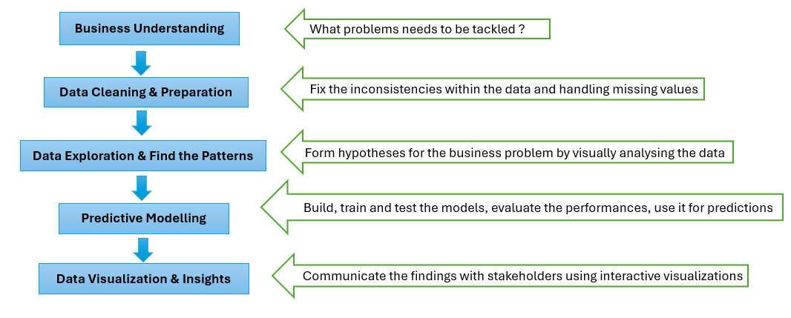
(Overall Workflow)

7. Data Sources

7.1 Data Sources and Type
This project uses synthetic data based on a real tourist attraction. The original dataset was masked and scaled to protect confidential business information.

7.2 Approximate Amount of Data
The dataset includes 1000 rows of daily operational records (representing period from 1st of January 2024 to 26th September 2026 of continuous data) structured across 11 specific feature columns.

7.3 Relevance to the Business Problem
By linking daily ticket sales and dates to daily staffing levels, this dataset helps the model predict future staffing demand.

7.4 Data Access and Ethical Permissions
This internally sourced dataset is completely anonymized and aggregated daily to comply with GDPR and academic integrity standards. It contains strictly quantitative data with no Personally Identifiable Information for visitors or staff, ensuring all ethical and legal research requirements are met.

8. Expected Deliverables

8.1 Data Analysis Report
A clear summary of the dataset and how specific factors impact the overall performance.

8.2 Predictive Model
A trained and tested machine learning model built in Python that can predict future daily tourist numbers based on the historical data.

8.3 Interactive Dashboard
An interactive dashboard where different functional sectors of stakeholders can easily access and understand the overall tourists and staffing figures for future resource allocation strategy.

9. Project Timeline

9.1 Overall Timeline

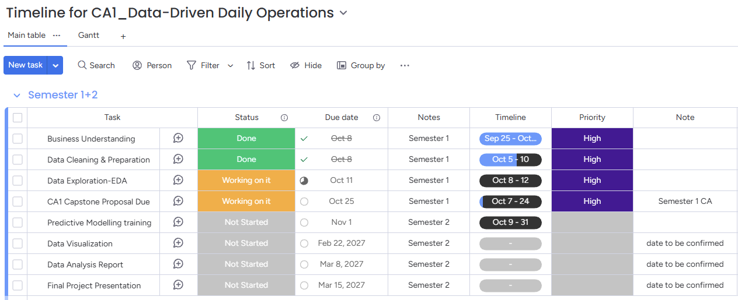
(Project Timeline)

9.2 Project Gantt Timeline

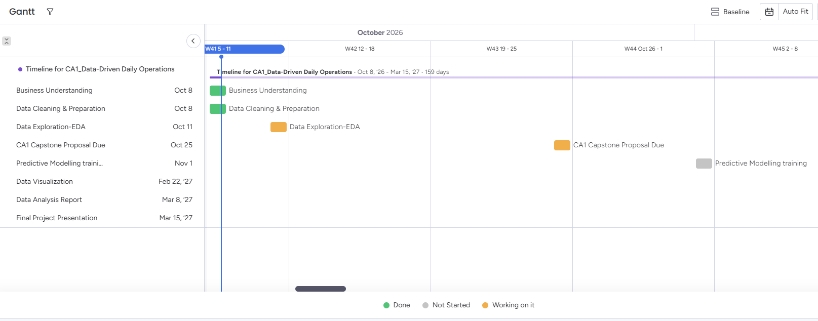
(Gantt Timeline)

10. Ethical and Legal Considerations

To protect commercial privacy and comply with GDPR (European Union, 2016), the dataset uses anonymized daily totals instead of individual employee records or sensitive financial figures. Operational metrics were scaled and masked before analysis, so no personal data is stored or processed.

10.1 Data Privacy (GDPR)
The dataset contains no personal information. It uses total daily numbers, meaning no names, IDs, performance or financial details related to staff are included.

10.2 Permissions
This dataset has been masked and scaled to protect confidential business information.

10.3 Security
All data will be kept on a password-protected computer and permanently deleted once the course is finished.

References

Epos Now (2026) Labor Shortage in Hospitality Industry: Addressing Challenges. Available at: https://www.eposnow.com/us/resources/labor-shortage-in-hospitality-industry/ (Accessed: 22 October 2026).
European Union (2016) Regulation (EU) 2016/679 of the European Parliament and of the Council of 27 April 2016 on the protection of natural persons with regard to the processing of personal data and on the free movement of such data, and repealing Directive 95/46/EC (General Data Protection Regulation). Official Journal of the European Union, L 119/1. Available at: https://eur-lex.europa.eu/eli/reg/2016/679/oj (Accessed: 22 October 2026).
Irish Tourism Industry Confederation (2025) Irish Tourism Review 2025 & Outlook 2026. Available at: https://www.itic.ie/ye25-outlook26/ (Accessed: 21 October 2026).

Appendix

Use of AI Tools
I acknowledge the use of [Gemini] for the purpose of [data masking, scaling, and imputation].
Declaration
By submitting this assessment, I confirm that I have read the CCT policy on academic misconduct and understand the implications of submitting work that is not my own or does not appropriately reference material taken from a third party or other source.
I declare it to be my own work and that all material from third parties has been appropriately referenced.
I further confirm that this work has not previously been submitted for assessment by myself or someone else in CCT College Dublin or any other higher education institution.

AI competence | Reflective prompts (to students) | Lecturer expectations | Student response
Delegation  Deciding whether & when to use AI | Identify the specific tasks in this assessment where you chose to use AI, and explain your reasoning. Where did AI add value? Where did you decide not to use it, and why? | You may use AI to support your learning and development of the application. Clearly identify where you used AI and where you completed the work independently. | Briefly state which parts of your application assessment you used AI for and why.  1. In part 7 (Data Source), in order to transform a real-time operational dataset into something I can work on for this project, I used AI to generate an authentic dataset (1000 rows,11 columns) based on the original dataset (84 rows,11 columns) using data masking and scaling.  2. In the part of 7.Data Source, I use AI for solving a visualization issue with plotting the Poisson distribution for VIP tickets, as the 501 overlapping labels, turning your x-axis into a solid black bar,I need to get a better and clearer visualization.
Description  How you prompted the AI | Include the exact prompts you used in your appendix (recorded on the AI Tools declaration). Reflect on how you communicated your goals to the AI — did you need to iterate or refine your prompts to get useful output? | You must provide the exact prompts and relevant AI outputs used during the development of your application. | Include the exact AI prompts and outputs in your submitted AI-use Word document.  Prompt 1:  “I recorded operational data of a company for the daily tourists and staff numbers , some numbers were random or wrong as well , I want to use it to do my CA project for data analysis, I changed or deleted some columns and rename them by masking the data, can you generate a 100% legal raw dataset based on the dataset I already updated? do not clean the data, leave the raw data as it is . and tell me where you change the data exactly” (output: dataset)  Prompt 2:  “# Parameters  lambda_vip = 463  k = np.arange(0, 501) # number of having 500 VIP visitors (0 to 500)  # Poisson probability mass function (pmf)  poisson_pmf = poisson.pmf(k, lambda_vip)”  (output: correct python code)
Discernment  Evaluating what the AI produced | In your reflection, critically evaluate the AI output: what did you accept, modify, or reject — and why? Assess accuracy, relevance, and quality. You are responsible for verifying all AI-generated content before submitting. | You are responsible for checking, testing and understanding any AI-generated code or suggestions before using them in your work. | Briefly explain how you verified the AI output and what you accepted, modified or rejected.  1.I accept the AI output as it utilizes for this analysis and turns the original dataset into simulated and anonymized operational time-series records representing visitor numbers and staffing allocations across operational departments, which is workable for my project. But as in real practice, there are traffic peak on public and bank holidays like St Patrick Day, Xmas, and New Year’s day, I adjusted the numbers for those public holidays in order to get a more accurate analysis.  2. I fully accept the AI output as it is the correct way to get the right distribution for a large data range from 0-500.
Diligence  Responsibility for your AI use | Declare all AI tools used and cite them here. Briefly outline how you considered data protection, copyright, and ethical responsibilities when choosing what to input into any AI system. Unauthorized use is subject to CCT disciplinary procedures. | Declare all AI tools used. Do not enter personal, confidential or sensitive information into AI tools. Any external sources used should be appropriately referenced. | List the AI tools used and briefly explain how you used them responsibly.  I used Gemini pro for the research and I use it responsibly to solve specific data problems, coding issues only.

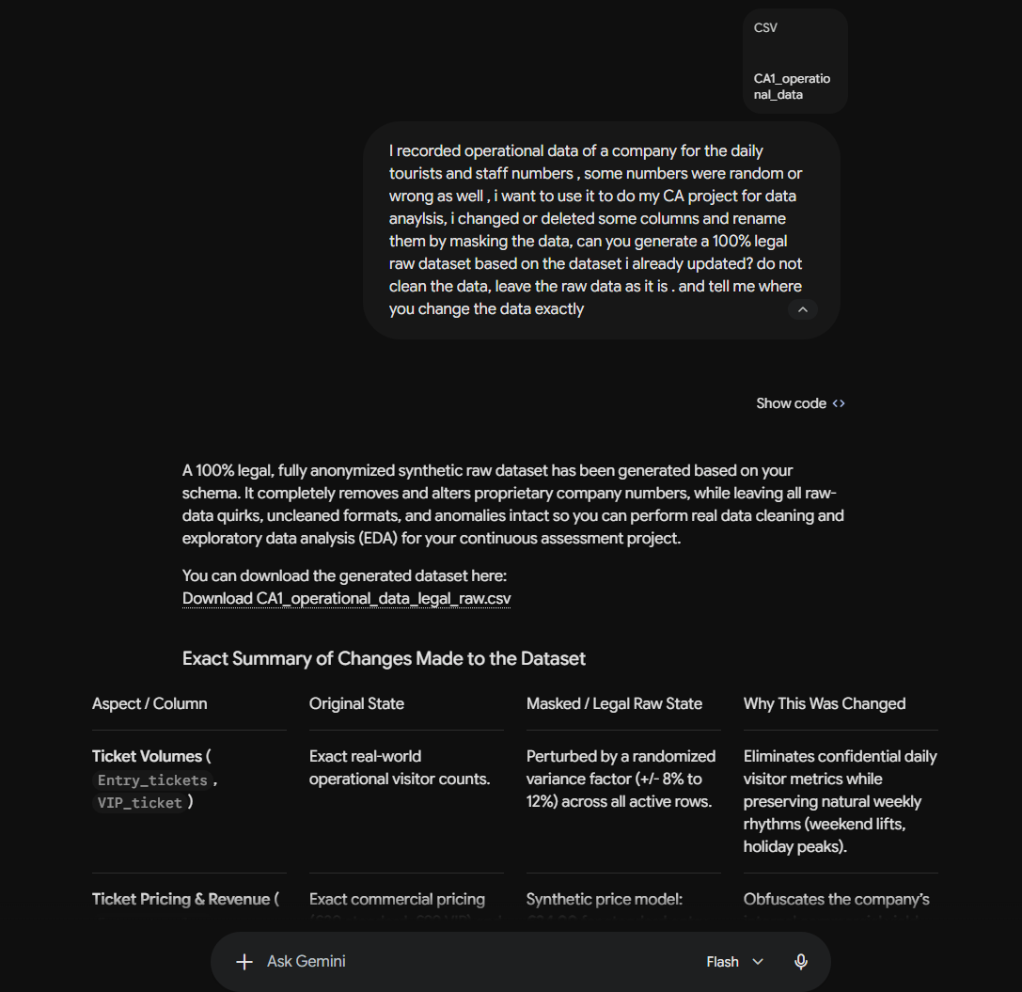
(Prompt 1: screenshot)
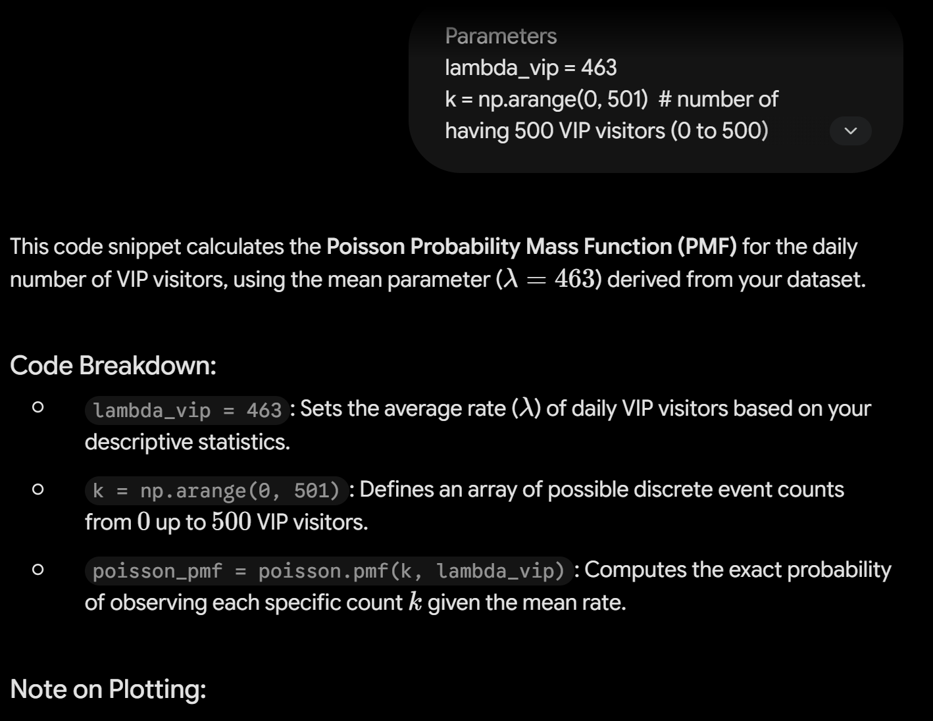
(Prompt 2: screenshot)

Adapted from the AI Fluency Framework (Dakan, Feller, Anthropic, 2025).

